REQUIREMENTS SPECIFICATIONS FOR MHE ELECTRONIC APPROVAL SYSTEM

28 DEC 2010

1 INTRODUCTION

This is a joint project by Logistics, IT and Procurement to evaluate the possibility of developing an electronic approval system for requisition of MHEs.

2 SCOPE OF SOLUTION

The solution would be utilised to cover:
a) Renewal of current fleet of MHE approx 200 units
b) New request for MHE
b) Total 42 logistics cost centres and 3 forwarding cost centres

3 CURRENT PROCEDURE
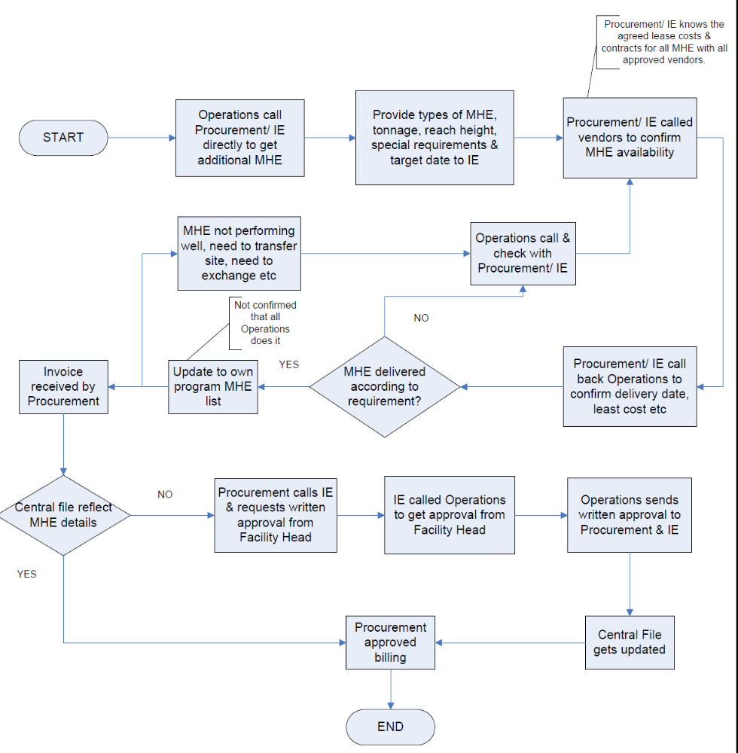

Based on the above workflow, the written approval is only sought after the MHE has been delivered and invoice received.

The process is also not efficient as it requires many rounds of co-ordination and clarifications amongst planner, users and procurement.

4 VISION

a) An electronic system that can monitor the whole process starting from a user’s request till the MHE is delivered.
b) Minimise paper flow between off-sites and main office
c) Proper approval process
d) Ensure only approved vendors are used.

5 REQUIREMENTS

a) Data base for approved vendors
b) Data base for selected models of MHE
c) Data base for all contracted MHE (details such as agreement number, machine model and serial number, to be further discussed)
d) Routing of request for approval based on authorisation chart
e) Generating monthly reports to track contract status and transfer of MHE between cost centres.

